Circumscribe
# Source: AI Source: Provided by: [Data Path: Persons Table -> ID Column: 1, Name_En Column: Motasem Essam] -> From: [ChatGPT] on [7/25/2026]
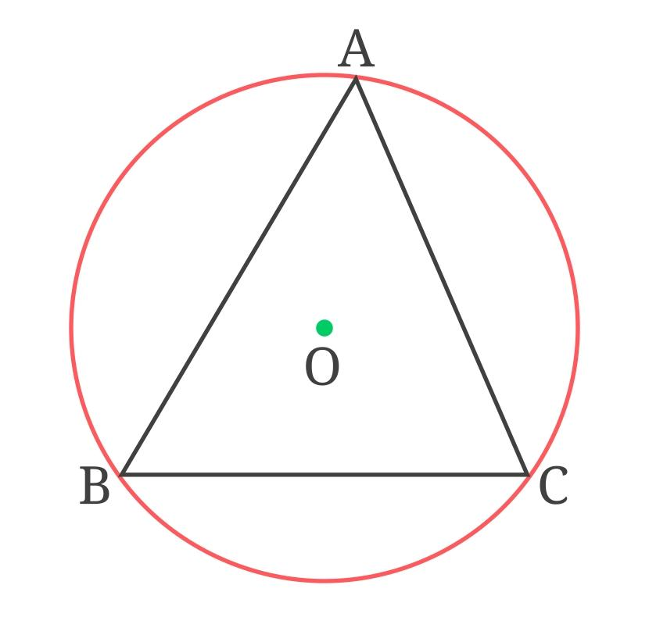
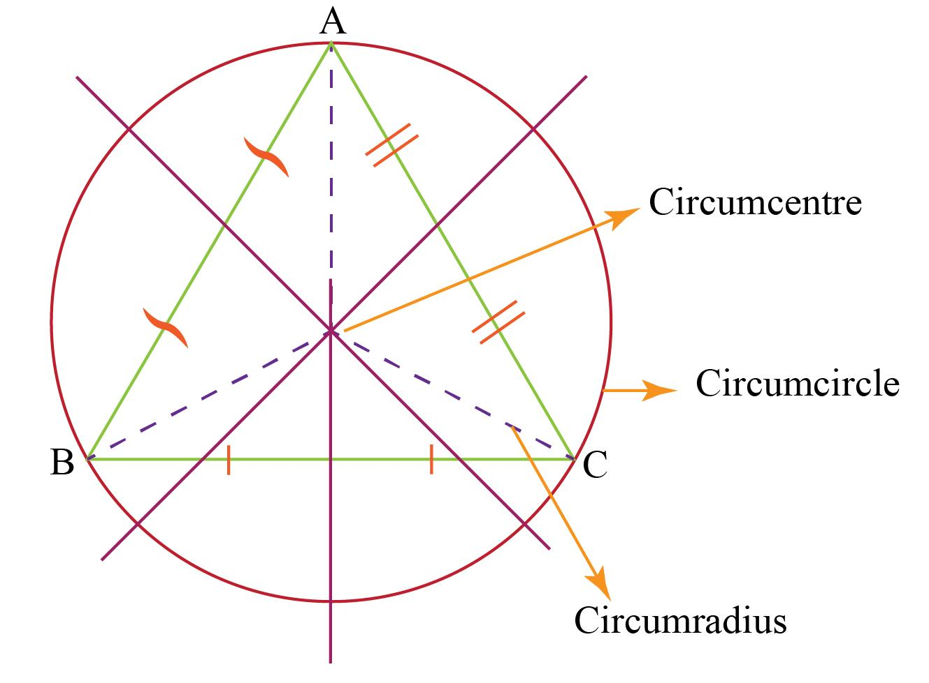
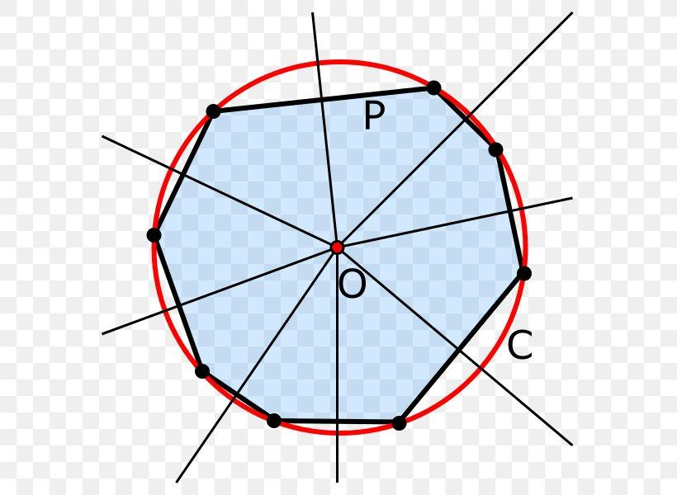
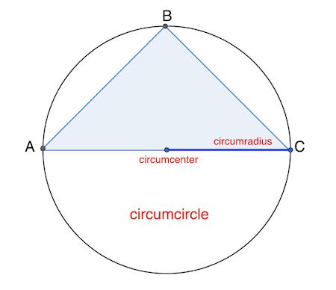
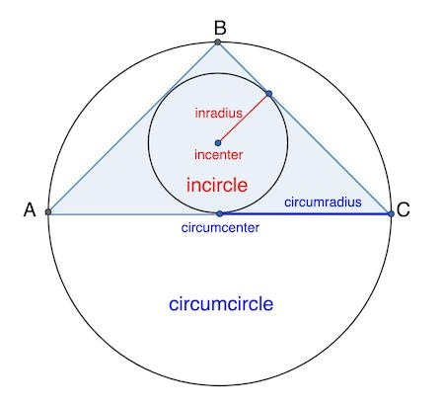

Definition
# Source: AI Source: Provided by: [Data Path: Persons Table -> ID Column: 1, Name_En Column: Motasem Essam] -> From: [ChatGPT] on [7/25/2026]
To circumscribe one geometric object around another means to place the first object around the second so that it satisfies a specific boundary condition.
In geometry, the term is commonly used in two ways:
- A circle circumscribes a polygon when the circle passes through all the polygon's vertices.
- A polygon circumscribes a circle when the circle lies inside the polygon and is tangent to all of its sides.

Main Types
# Source: AI Source: Provided by: [Data Path: Persons Table -> ID Column: 1, Name_En Column: Motasem Essam] -> From: [ChatGPT] on [7/25/2026]
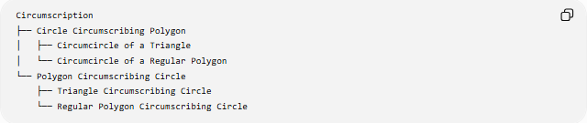
Circumscription
├── Circle Circumscribing Polygon
│ ├── Circumcircle of a Triangle
│ └── Circumcircle of a Regular Polygon
└── Polygon Circumscribing Circle
├── Triangle Circumscribing Circle
└── Regular Polygon Circumscribing Circle

Circle Circumscribing a Polygon
A circle circumscribes a polygon when every vertex of the polygon lies on the circle.
For triangle $ABC$:
$$A,B,C∈\text{Circumcircle}$$
The center of this circle is the circumcenter, and its radius is the circumradius $R$.
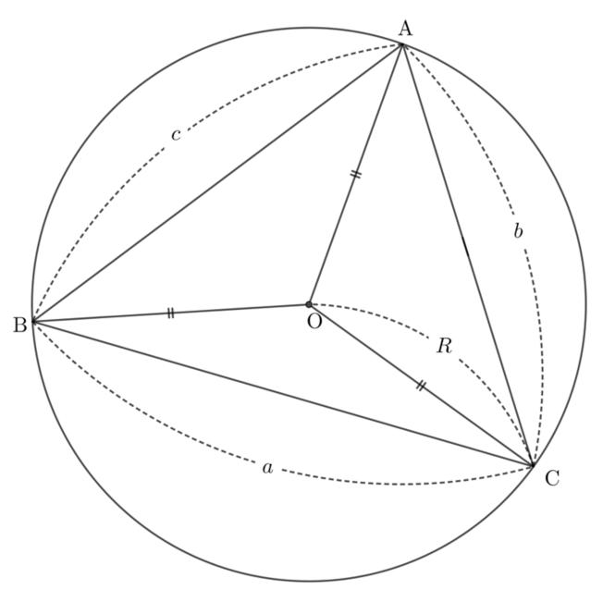
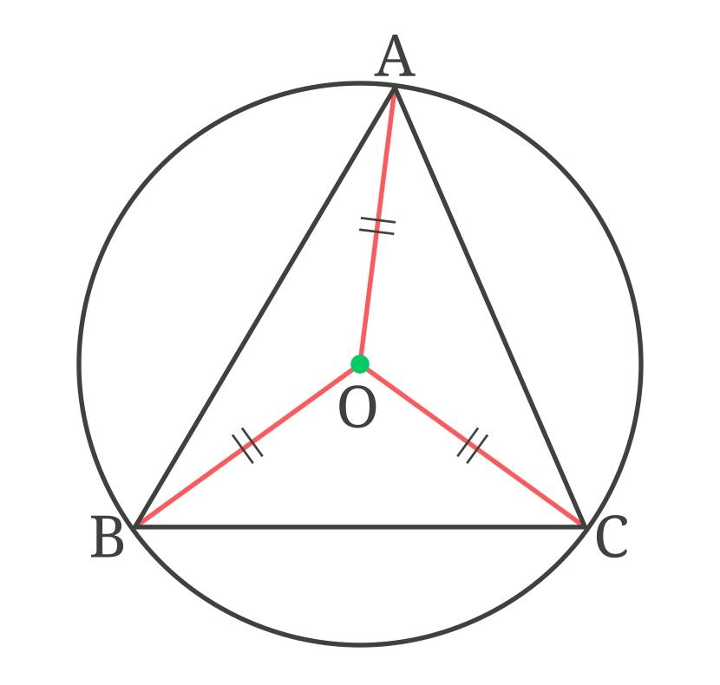
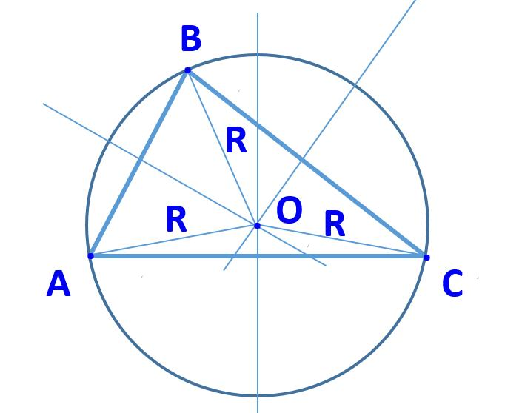
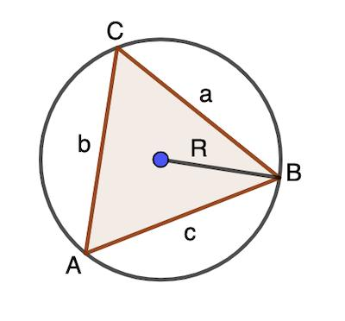

Polygon Circumscribing a Circle
# Source: AI Source: Provided by: [Data Path: Persons Table -> ID Column: 1, Name_En Column: Motasem Essam] -> From: [ChatGPT] on [7/25/2026]
A polygon circumscribes a circle when the circle lies inside the polygon and touches each side.
For a triangle, this circle is the incircle.
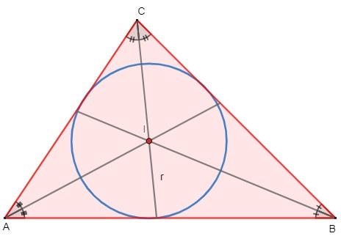
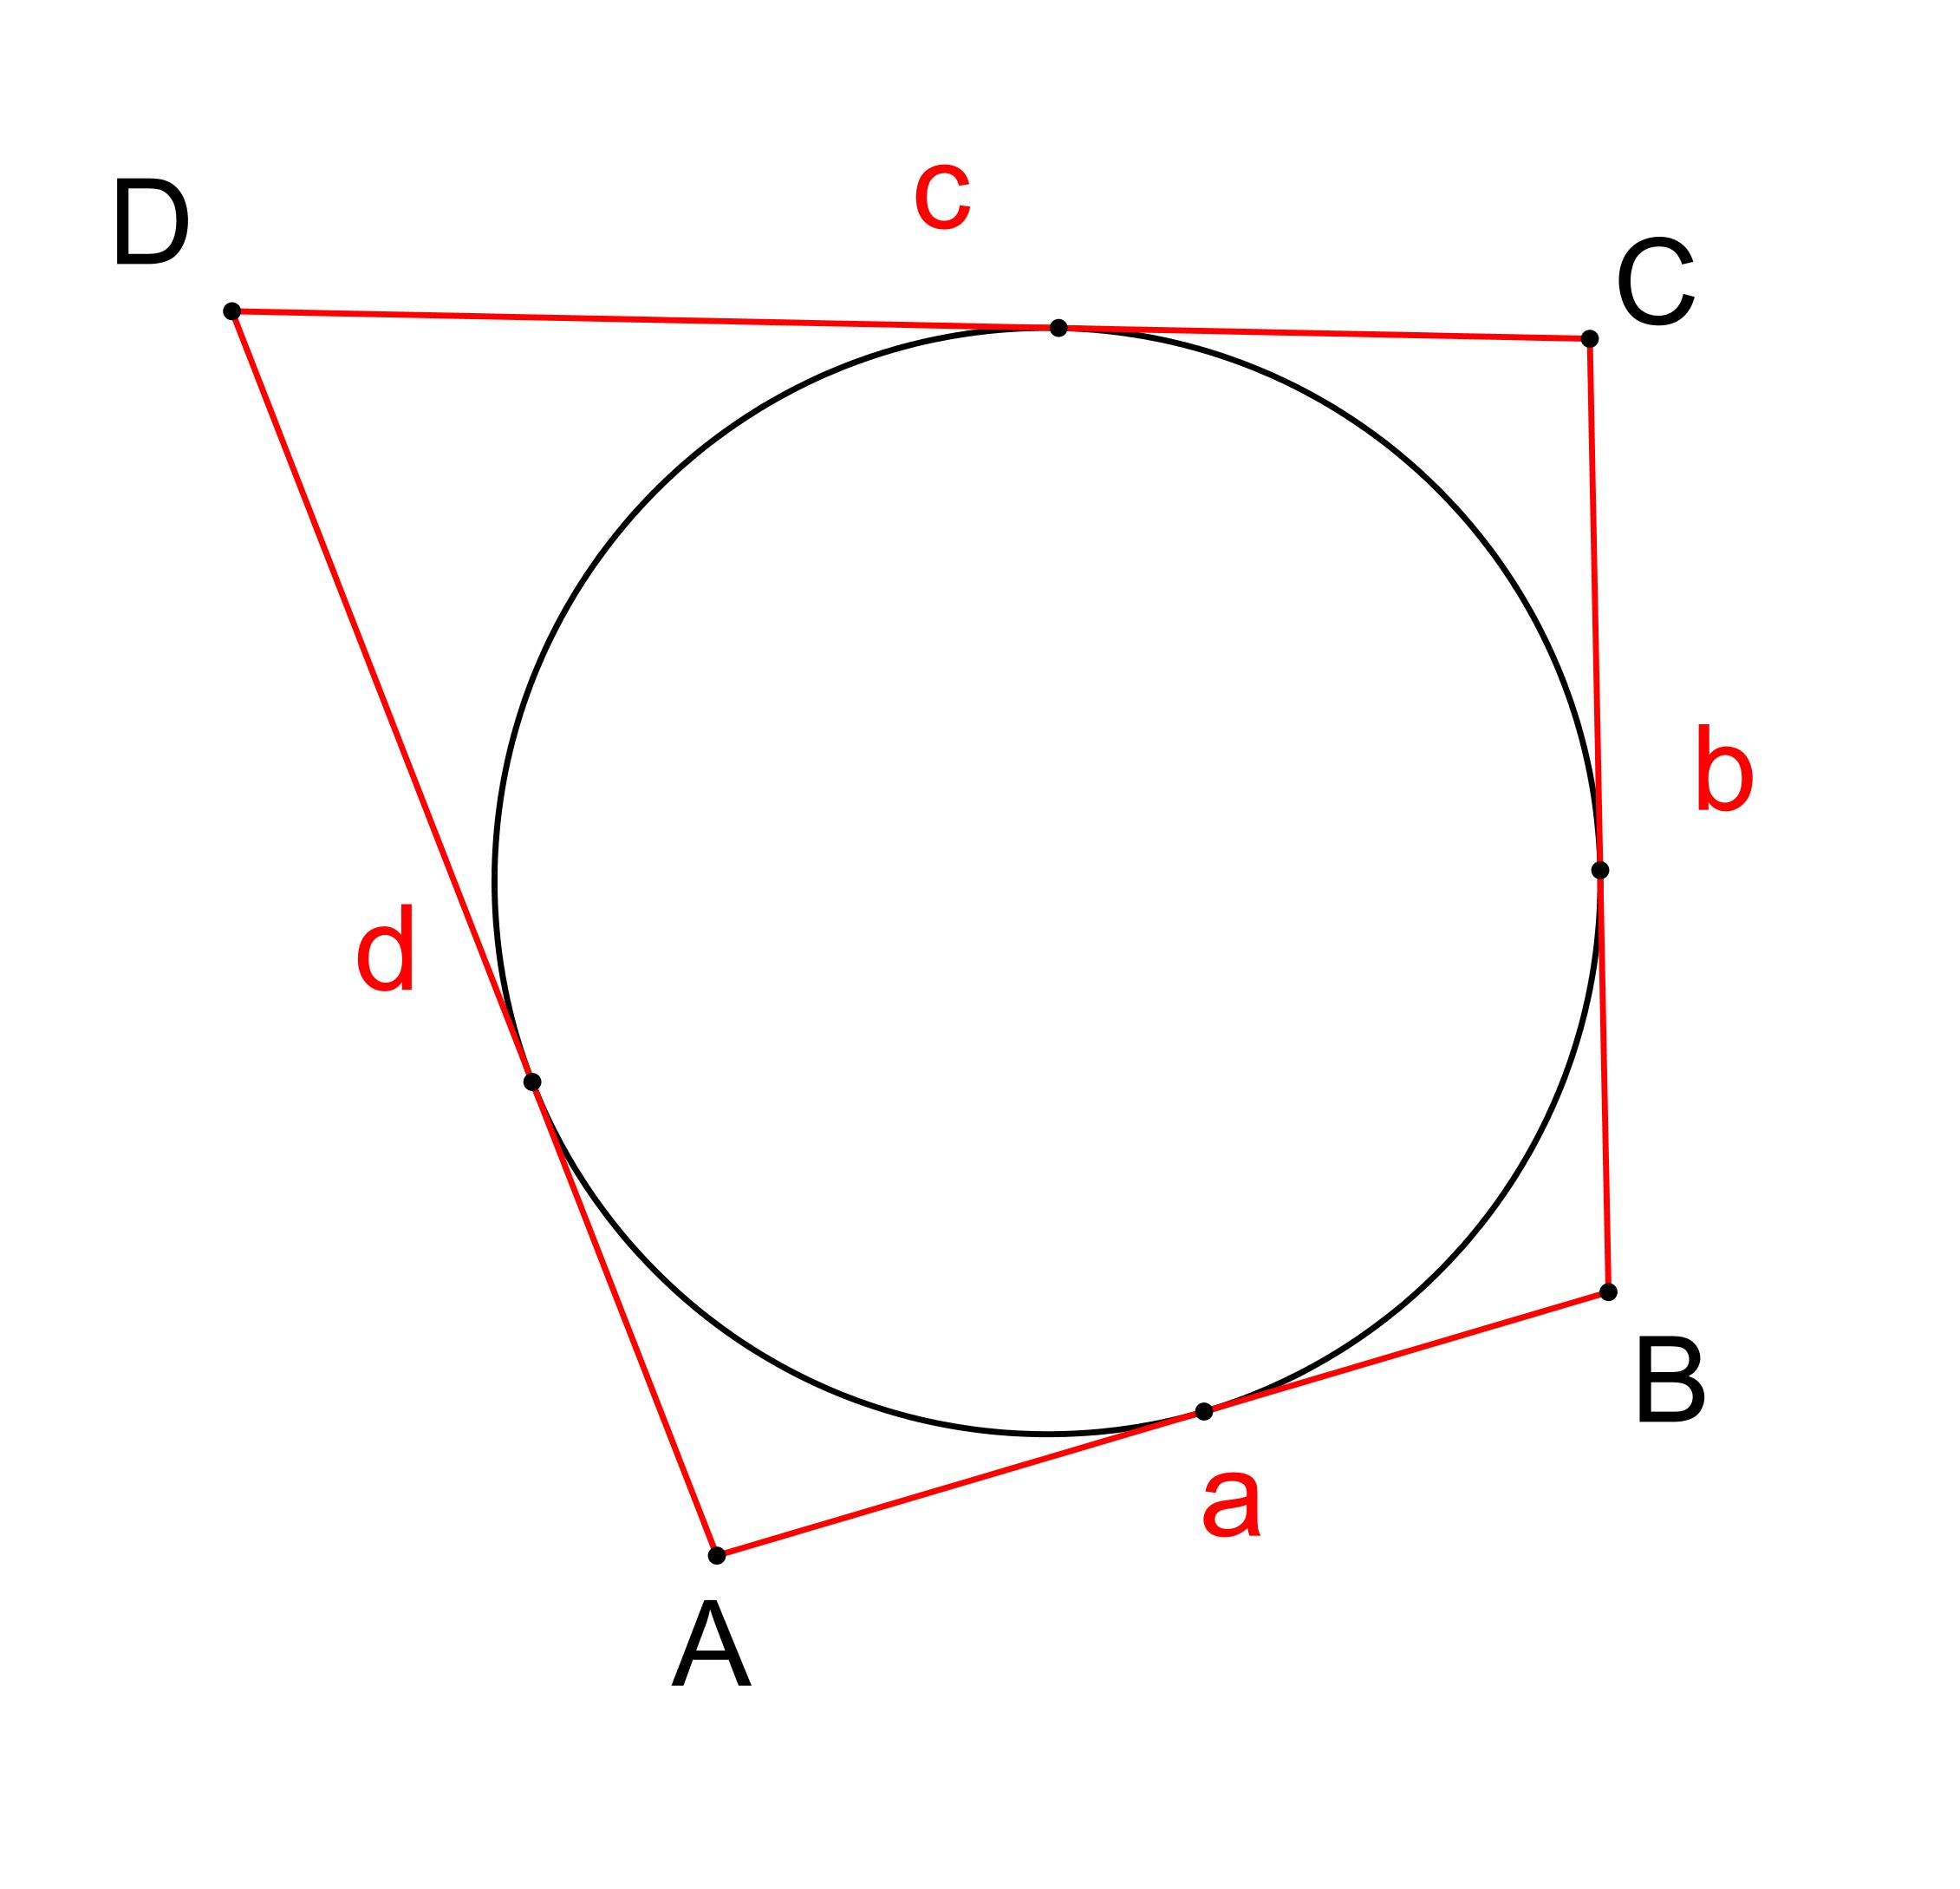
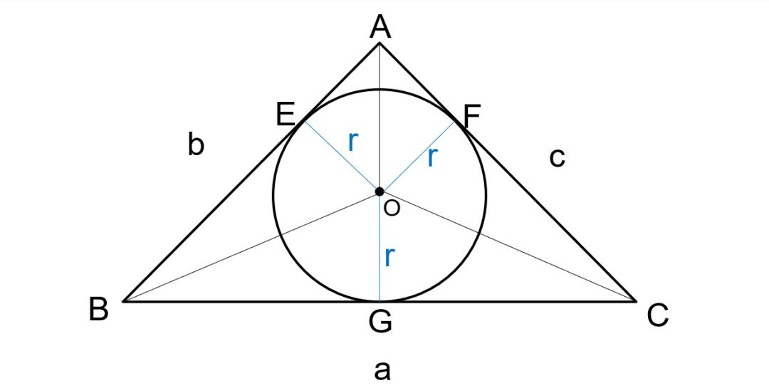
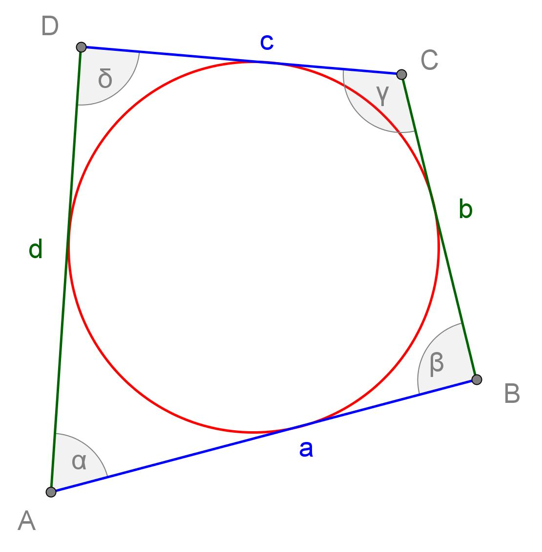

Circumscribe vs Inscribe
# Source: AI Source: Provided by: [Data Path: Persons Table -> ID Column: 1, Name_En Column: Motasem Essam] -> From: [ChatGPT] on [7/25/2026]
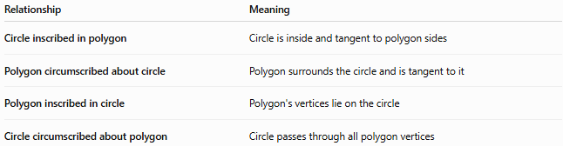
Relationship | Meaning
Circle inscribed in polygon | Circle is inside and tangent to polygon sides
Polygon circumscribed about circle | Polygon surrounds the circle and is tangent to it
Polygon inscribed in circle | Polygon's vertices lie on the circle
Circle circumscribed about polygon | Circle passes through all polygon vertices
These are complementary descriptions of the same geometric relationships.
Circumradius
When a circle circumscribes a polygon, its radius is called the circumradius.
For a triangle:
$$\boxed{R=\frac{abc}{4A}}$$
where $a,b,c$are the side lengths and $A$is the triangle's area.
For a regular $n$-gon with side length $a$:
$$\boxed{R=\frac{a}{2sin⁡\left(\frac{π}{n}\right)}}$$

Example
# Source: AI Source: Provided by: [Data Path: Persons Table -> ID Column: 1, Name_En Column: Motasem Essam] -> From: [ChatGPT] on [7/25/2026]
For an equilateral triangle with side $a$:
$$\boxed{R=\frac{a}{\sqrt{3}}}$$
while its inradius is:
$$\boxed{r=\frac{a}{2\sqrt{3}}}$$
Thus:
$$\boxed{R=2r}$$

Related Concepts
# Source: AI Source: Provided by: [Data Path: Persons Table -> ID Column: 1, Name_En Column: Motasem Essam] -> From: [ChatGPT] on [7/25/2026]
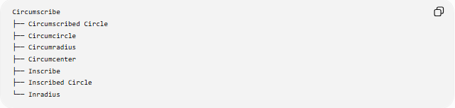
Circumscribe
├── Circumscribed Circle
├── Circumcircle
├── Circumradius
├── Circumcenter
├── Inscribe
├── Inscribed Circle
└── Inradius

Key Point
# Source: AI Source: Provided by: [Data Path: Persons Table -> ID Column: 1, Name_En Column: Motasem Essam] -> From: [ChatGPT] on [7/25/2026]
Inscribe means an object is placed inside another according to the required boundary condition.
Circumscribe means an object is placed around another according to the required boundary condition.

